Practical
SUMMARY:-
In this practical, I studied different sorting methods and learned how they arrange numbers from smallest to largest.

Merge sort divides the array into smaller parts, sorts them, and merges them into a sorted array.

Output
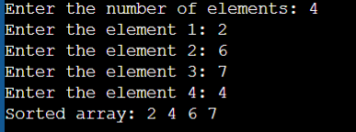

Time Complexity:
Best Case O(n log n)
Average Case O(n log n)
Worst Case O(n log n)

Quick Sort chooses a pivot, partitions the array around it, and recursively sorts the partitions.

Output
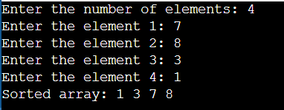

Time Complexity:
Best Case O(n log n)
Average Case O(n log n)
Worst Case O(n²)

Conclusion-This practical helped in understanding the working of Quick Sort and Merge Sort algorithms. Both algorithms sort data efficiently using the divide-and-conquer technique. Quick Sort is generally faster for average cases and requires less memory, while Merge Sort provides stable sorting and guarantees O(n log n) time complexity. By implementing both algorithms, we learned their logic, performance, and suitable use cases for different types of data.

